CONTACT DETAILS
Prof. B. N. Shashidhar
Principal
Degree & PG Studies
Sree Kongadiyappa College

College Tel: 080-27623759
Mobile: 9448076253
E-mail: shashidharbn.23@gmail.com
Residence
“SAI GANGA”
Opp Lavanya PU College
Subhash Nagar
Doddaballapur-561203
Res Tel: 080-27625392

FACILITIES AVAILABLE
- College prospectus
- College magazine “Kirana”
- IQAC
- NCC
- NSS
- Placement cell
- Health center
- Counselling cell
- Woman grievance redressal Cell
- Alumni association
- Parents – Teachers’ meet
- Anti Sexual harassment/Anti ragging cell
- Maths lab
- Chemistry lab-02 Nos.
- Physics lab-02 Nos.
- Conference hall
- Power generating system
- Smart class rooms-04 Nos.
- Separate PG & Commerce block
- Bio-Metric system
- CC TV at different places
- Purified drinking water facility
- Well stocked central library
- Computer center with free Internet facility
- INFLIBNET-e Library
- UGC Network resource centre
- Ladies rest rooms
- Computerized office
- Parking slot
- Outdoor & Indoor sports facility
- Well maintained lawn in the quadrangle
- Canteen

BEST PRACTICES

- Mid-day meal scheme for rural students
- Blood donation camp
- National Integrationcamp
- Patents – Teachers’ meet
- Spoken English classes
- Certificate Course on soft skills
- NSS & NCC camps in the rural areas
- Literacy programs
- Programs on swatch bharath
- Anti-Terrorism programs
- Woman’s day celebrations
- Health Check-up camps for girl students
- Aids awareness programs

Rank holders of the Institution
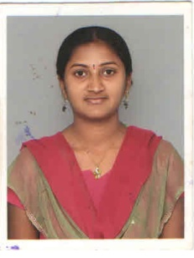
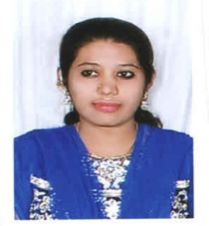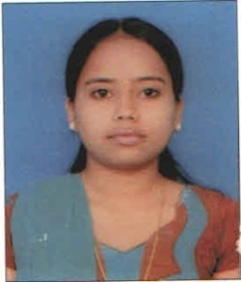

L.M. Sushma Naziaya Chitralekha M.
B.Sc 9th Rank B.Com 7th Rank B.Com 3rd Rank
2011-12 2012-13 2013-14
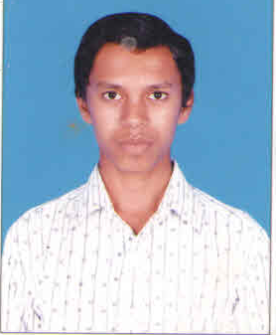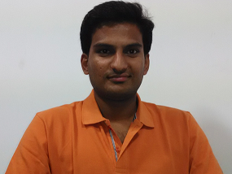

T. P. Sunil D.T. Shiva Kumar
B.Com 2nd Rank B.Sc 2nd Rank
2012-13 2011-12
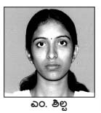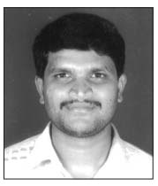

M. Shilpa Ashok T.A.
B.A 7th Rank B.A. 10th Rank
2011-12 2010-11

PHOTO GALARY

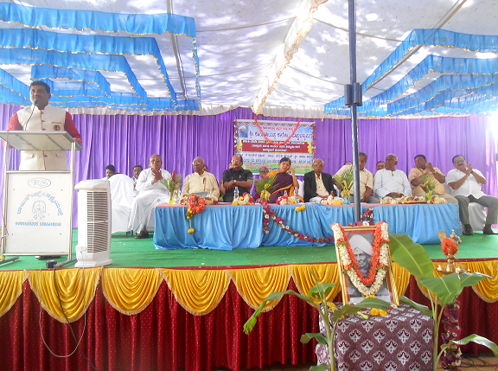

COLLEGE DAY FUNCTION

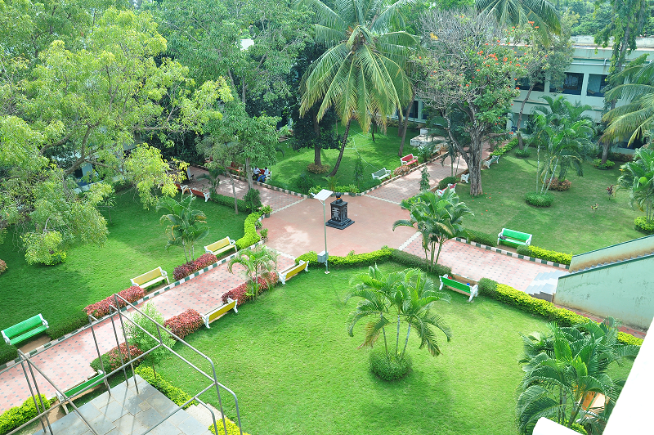

COLLEGE QUADRANGLE

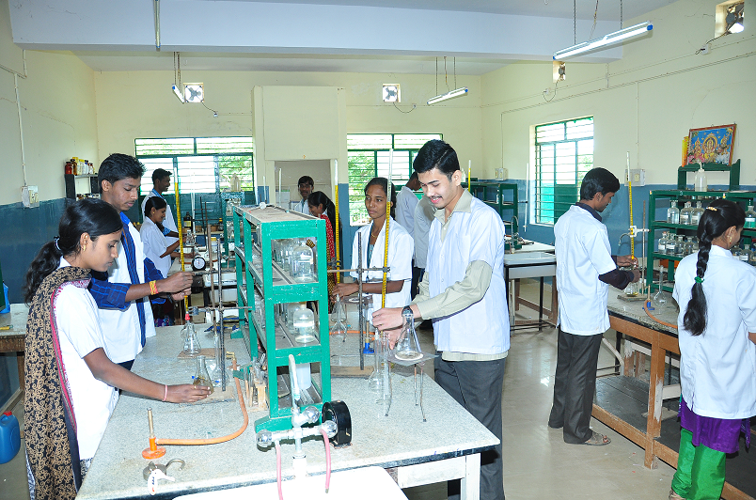

CHEMISTRY LAB

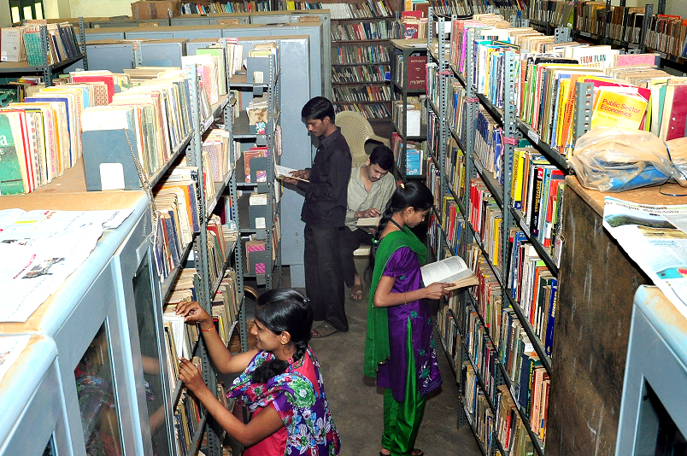

LIBRARY

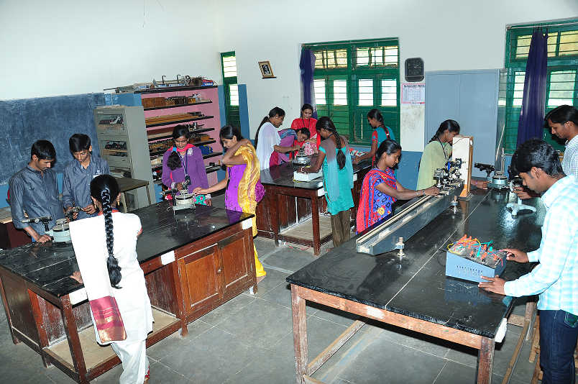

PHYSICS LAB

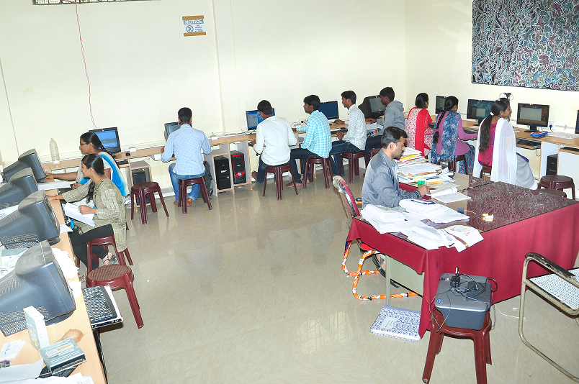

COMPUTER LAB

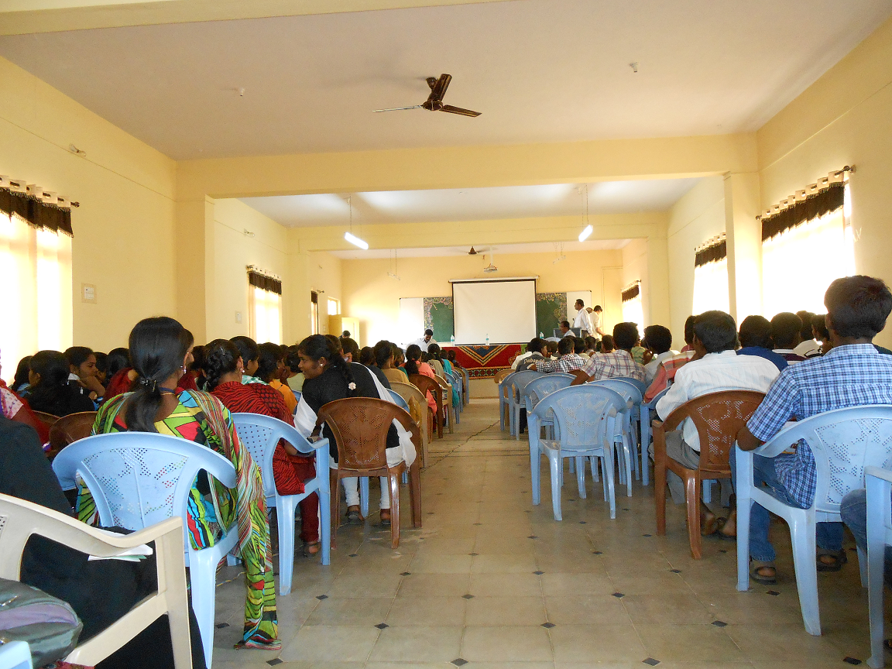

SEMINAR HALL

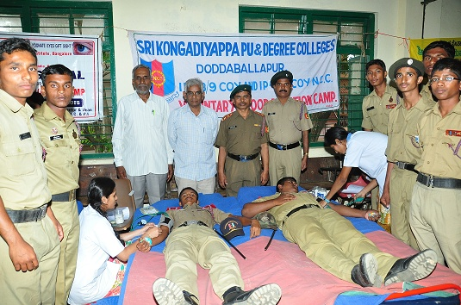
BLOOD DONATION CAMP

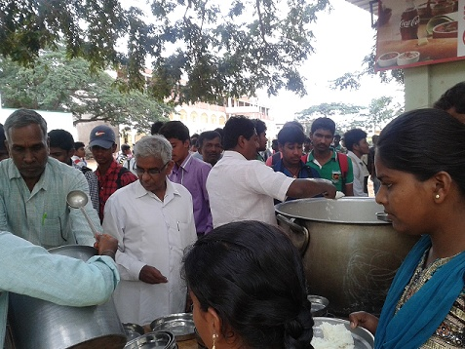
MID-DAY MEAL

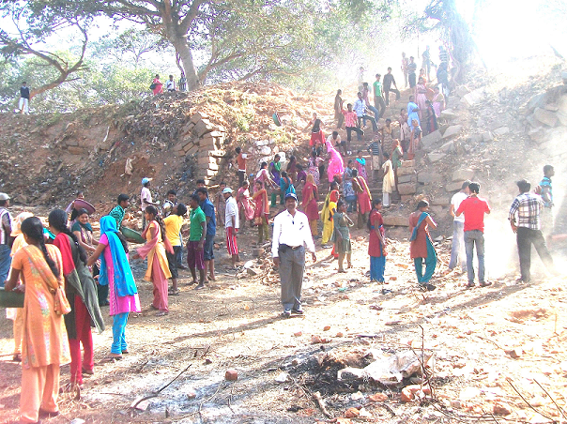
NSS ACTIVITY

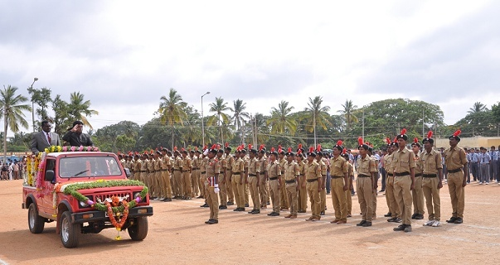
NCC UNIT
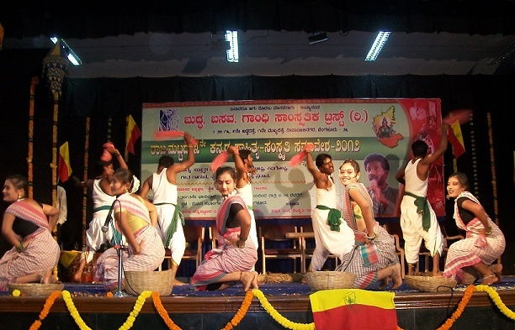
FOLK DANCE

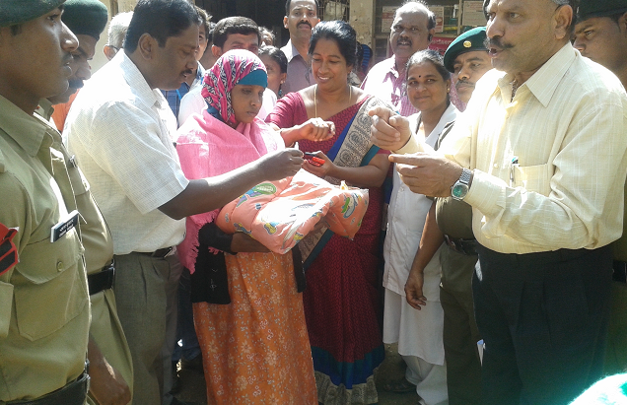
PULS – POLIO PROGRAMME

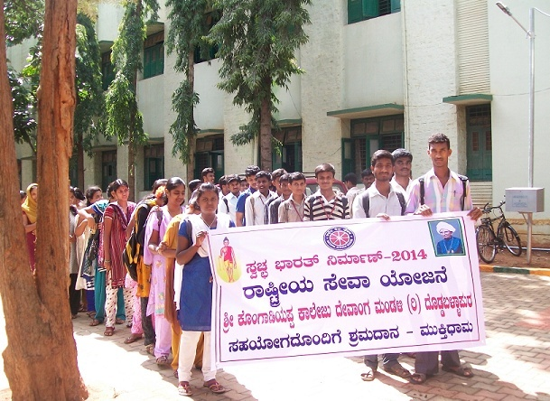
SWATCH BHARATH AWARENESS PROGRAMME
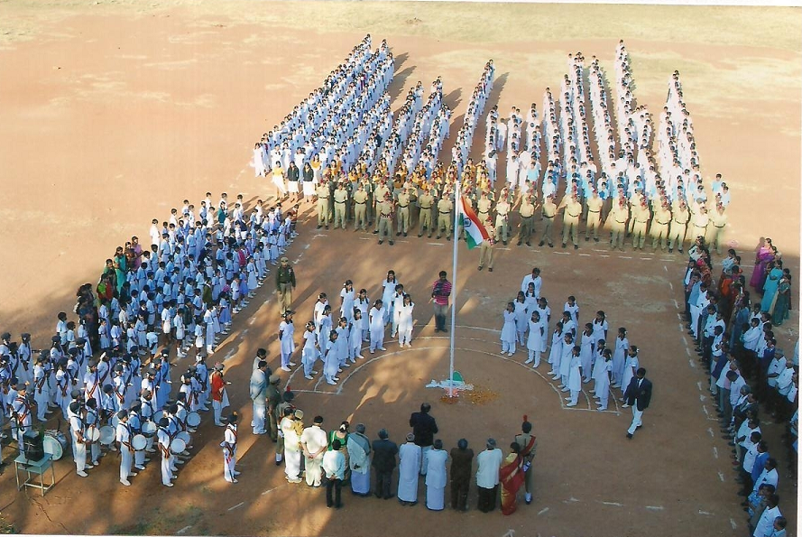
INDEPENDENCE DAY CELEBRATION

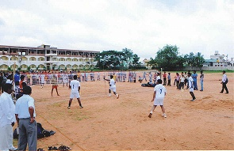
INTER COLLEGIATE BALL BADMINTON TOUNAMENT

