Alumni and Feedback forms

Project Name: Kongadiyappa College

Completed by: Deepu R
Sree Kongadiyappa College was established in the year 1973 at Doddaballapur. The college provides all the facilities for the students to turn entrepreneurs and professionals. Since its inception in 1973 it has tried to pursue excellence in every aspect it touches whether academics, infrastructural or environmental. We have prepared a questionnaire for you to give us feedback about our institute and its system.
Now Kongadiyappa College has started to collect feedback and valuable suggestions for future improvement of the institute. Students and Parents valuable inputs will be of great use to improve the quality of College academic programs and enhance the credibility of the institute.
We have incorporated Feedback and Alumni forms in Kongadiyappa college website. This needs to be filled by Students and Parents.
Forms:
- Alumni Membership Registration form: In this form Students Personal, Academic, Contact and Professional information’s will be collected.

- Alumni Feedback Form: In this form suggestions and overall assessment of college will be collected in rating.

- Parent Feedback form: In this form Parents information, Suggestions and answers for Questionnaire will be collected.

- Student’s feedback on teachers: In this form students needs to give feedback of teachers, Questionnaire will be provided students needs to submit their answers in rating.

- Student’s Feedback on courses: In this form students needs to give feedback of the course, Questionnaire will be provided students needs to submit their answers in rating.
Steps to be performed by the college staff to create the initial data for the Feedback and other Forms
- Go to kongadiyappa website home page. (http://www.kongadiyappacollege.com)
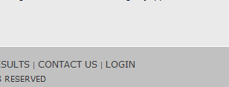
- Click on the Login Link in the footer.
- Enter User Name and Password.
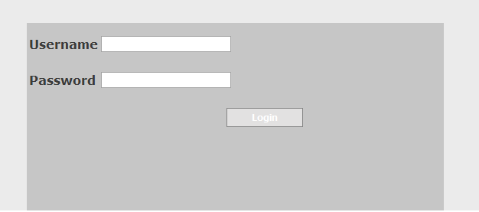
- After logging in the navigation bar with the links are shown.
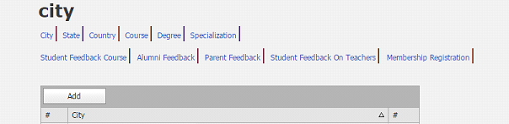
- You can add a new entry by clicking on the Add Button
- To change any existing entry click on the Edit Link on that particular row (Change an existing entry only if you are sure the same is not already used in any of the forms. If the entry is already used, then the changes will get reflected in the existing forms also)
- To delete any existing entry click on the Delete Link on that particular row (The entry cannot be deleted if it is already used in any of the forms)
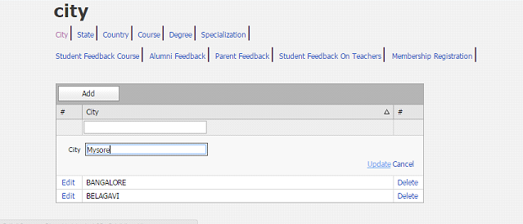
- Enter the required cities as shown above
- Do the same for State, Country, Course, Degree, Specialization
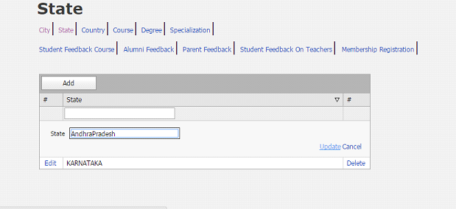
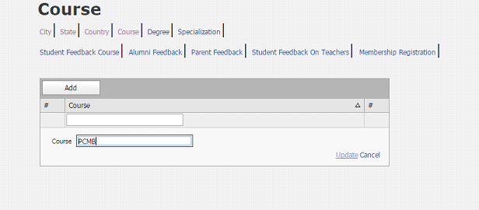
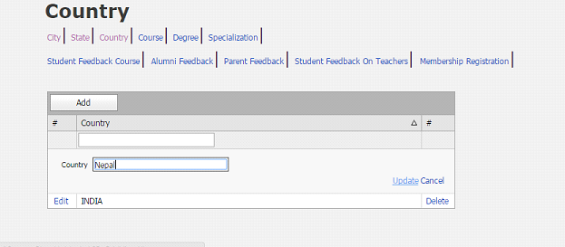
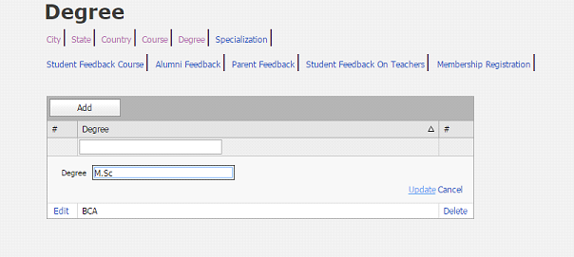
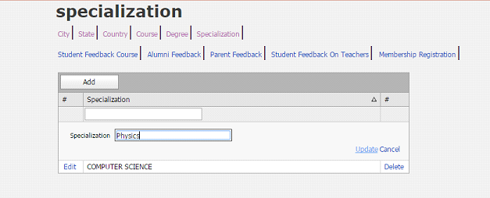
Steps performed by the college staff to view the alumni details available in the database:
- Go to kongadiyappa website home page. (http://www.kongadiyappacollege.com)
- Click on the Login Link in the footer.
- Enter User Name and Password.
- Once you logged in you can find set of links like
4.1. Student feedback on courses.
4.2. Alumni feedback on college.
4.3. Parent feedback on college.
4.4. Student feedback on teachers.
4.5. Alumni registration form.
- Click Student feedback on courses link .
- Now click on view button to view the complete information about the Student feedback on courses.
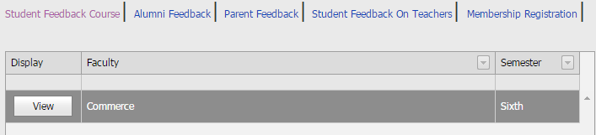

- Do the same to view the details using remaining Student feedback on teachers, Parent Feedback, Alumni feedback on college, Alumni registration form links.
